EXPT NO: 9 | TRANSFORMER-BASED LLM CHATBOT USING STREAMLIT OR GRADIO
DATE: 2/11/2026 | TRANSFORMER-BASED LLM CHATBOT USING STREAMLIT OR GRADIO

PRE-LAB QUESTIONS (PROVIDE BRIEF ANSWERS TO THE FOLLOWING QUESTIONS)

- Explain the basic architecture of a Transformer-based LLM.

A Transformer-based LLM consists of an Encoder and/or Decoder architecture. It uses self-attention mechanisms to understand relationships between words and neural network layers to process text and generate meaningful responses.

- What is the role of tokenization in LLM response generation?

Tokenization converts input text into smaller units called tokens (words, subwords or characters). These tokens are converted into numerical IDs that the LLM can understand and process.

- Explain how a pre-trained LLM generates responses to user queries.

A pre-trained LLM processes the user's prompt, converts it into tokens and predicts the next token based on learned patterns. It continues predicting tokens until a complete response is generated or the maximum output length is reached.

- Differentiate between Streamlit and Gradio.

Streamlit | Gradio
Used to build interactive web applications. | Used to build simple interfaces for ML models.
Suitable for dashboards and data applications. | Suitable for demonstrating AI and ML models.
Provides widgets like buttons, sliders and charts. | Provides ready-made inputs and outputs like textboxes and chat interfaces.
Mainly uses Python scripts. | Mainly uses Python functions and interface components.

- State the purpose of temperature and maximum output length in text generation.

  - Temperature: Controls the randomness of generated responses. Lower temperature produces more predictable responses, while higher temperature produces more varied responses.
  - Maximum output length: Specifies the maximum number of tokens the model can generate in a response.

AIM
To develop an interactive chatbot using a pre-trained Transformer-based LLM and deploy it using Streamlit or Gradio.

SOFTWARE REQUIREMENTS
- Python
- TensorFlow / Keras / PyTorch
- Google Colab
- GitHub
- Hugging Face Transformers
- PyTorch
- Streamlit or Gradio

OBJECTIVES
Students will be able to:
- Understand the working of Transformer-based LLMs.
- Load and configure a pre-trained LLM.
- Generate responses using user prompts.
- Develop an interactive chatbot using Streamlit or Gradio.
- Test and deploy the application.

PROCEDURE
PART A: LOADING AND CONFIGURING A PRE-TRAINED LLM
Perform the following tasks:
- Select a suitable pre-trained LLM using Hugging Face Transformers.
- Load the model and its tokenizer.
- Prepare and tokenize sample user prompts.
- Generate responses by configuring suitable parameters, such as temperature and maximum output length.
- Display and examine the generated responses.

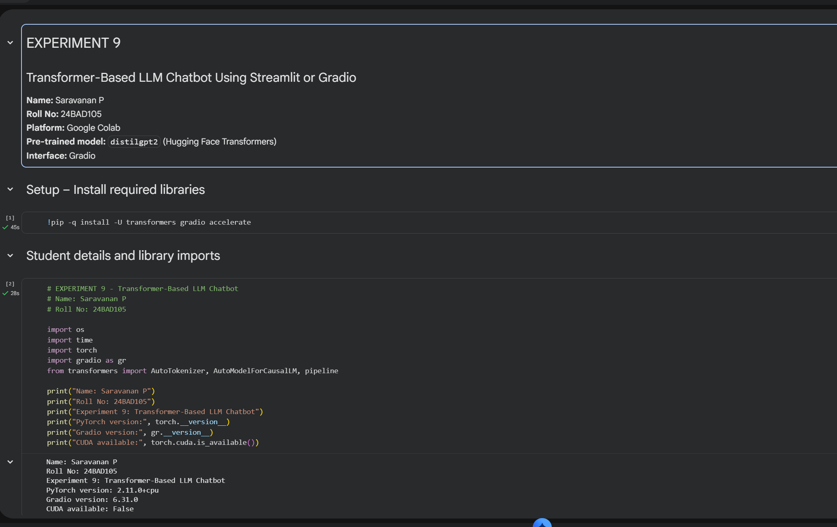
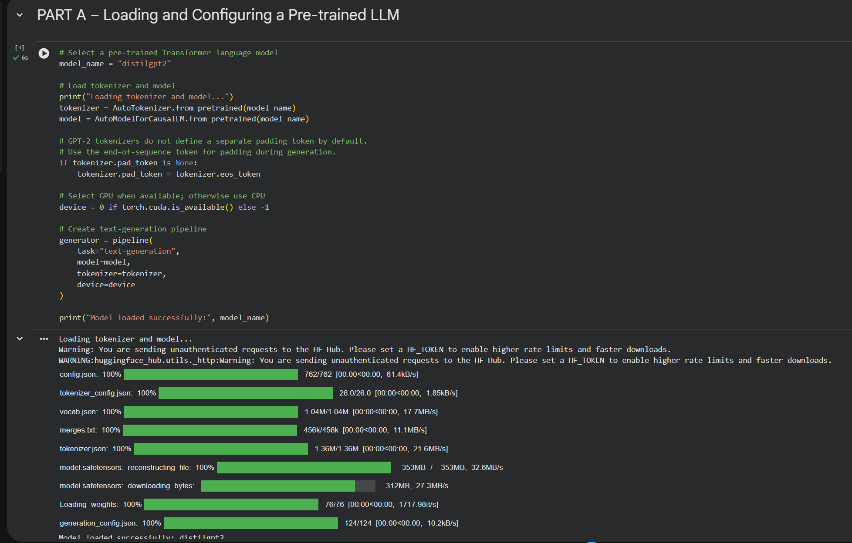

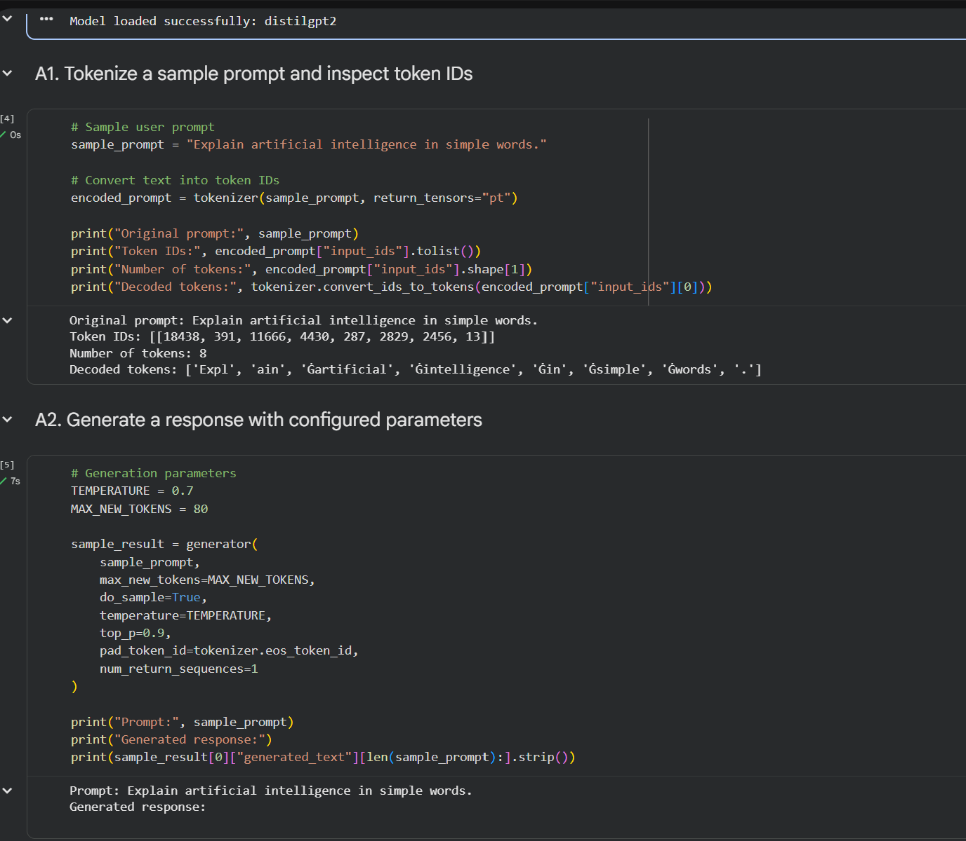

PART B: IMPLEMENTING CHATBOT FUNCTIONALITY

Perform the following tasks:
- Create a function to accept user queries and generate responses using the loaded LLM.
- Construct suitable prompts and display the generated responses.
- Maintain conversation history, if supported by the model.
- Test the chatbot with different queries and observe response quality.

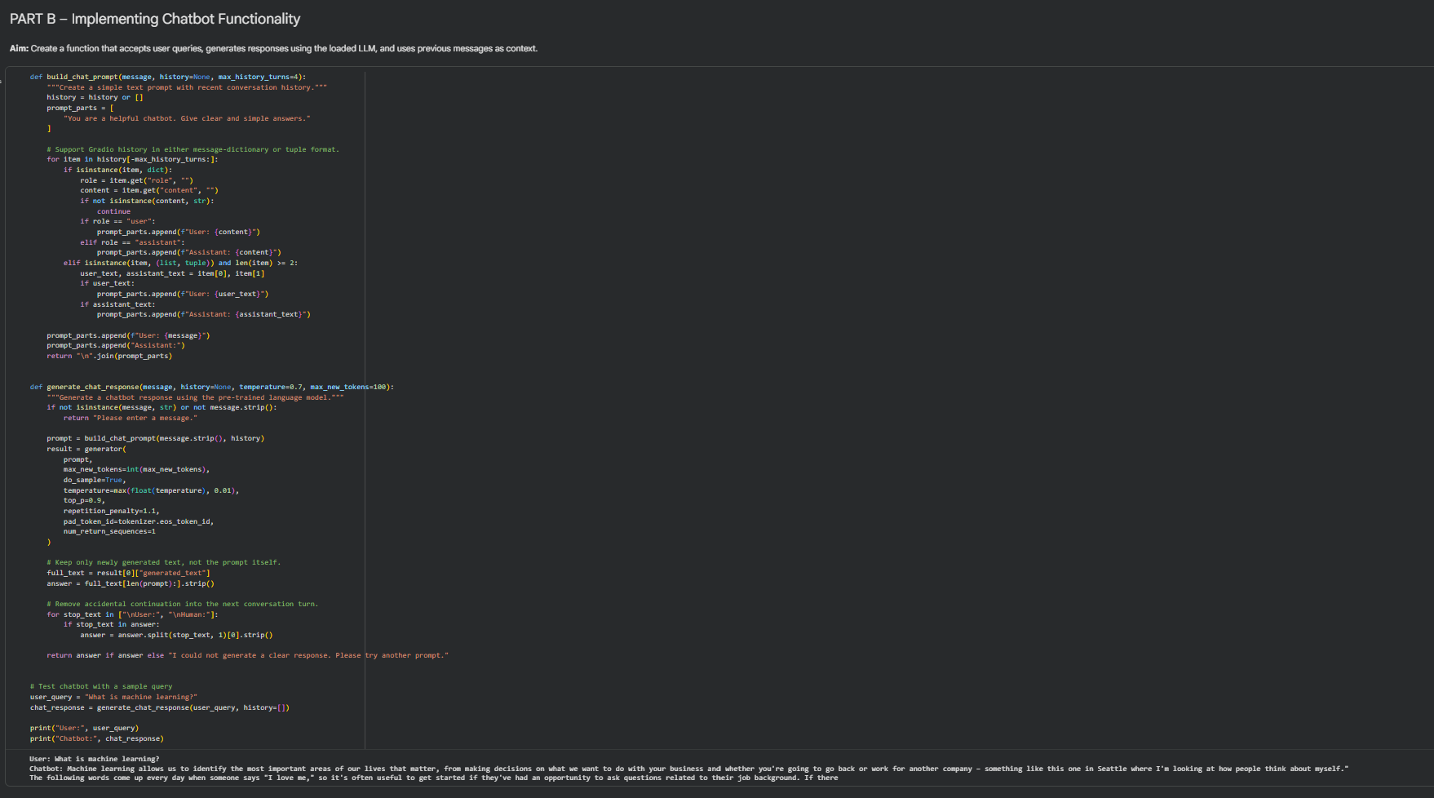

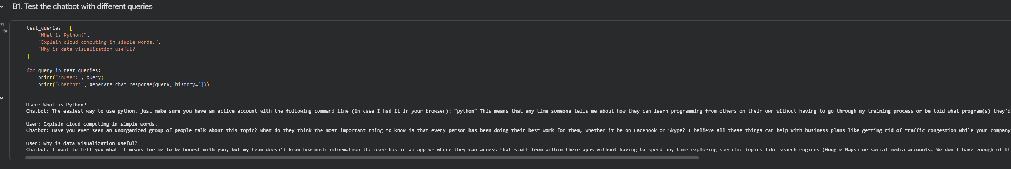

PART C: DEVELOPING AN INTERACTIVE INTERFACE

Perform the following tasks:
- Select Streamlit or Gradio to develop the chatbot interface.
- Create a text input component and a submission mechanism.
- Connect the interface to the LLM response-generation function.
- Display responses in a chat-style layout.
- Run and test the application with different user inputs.

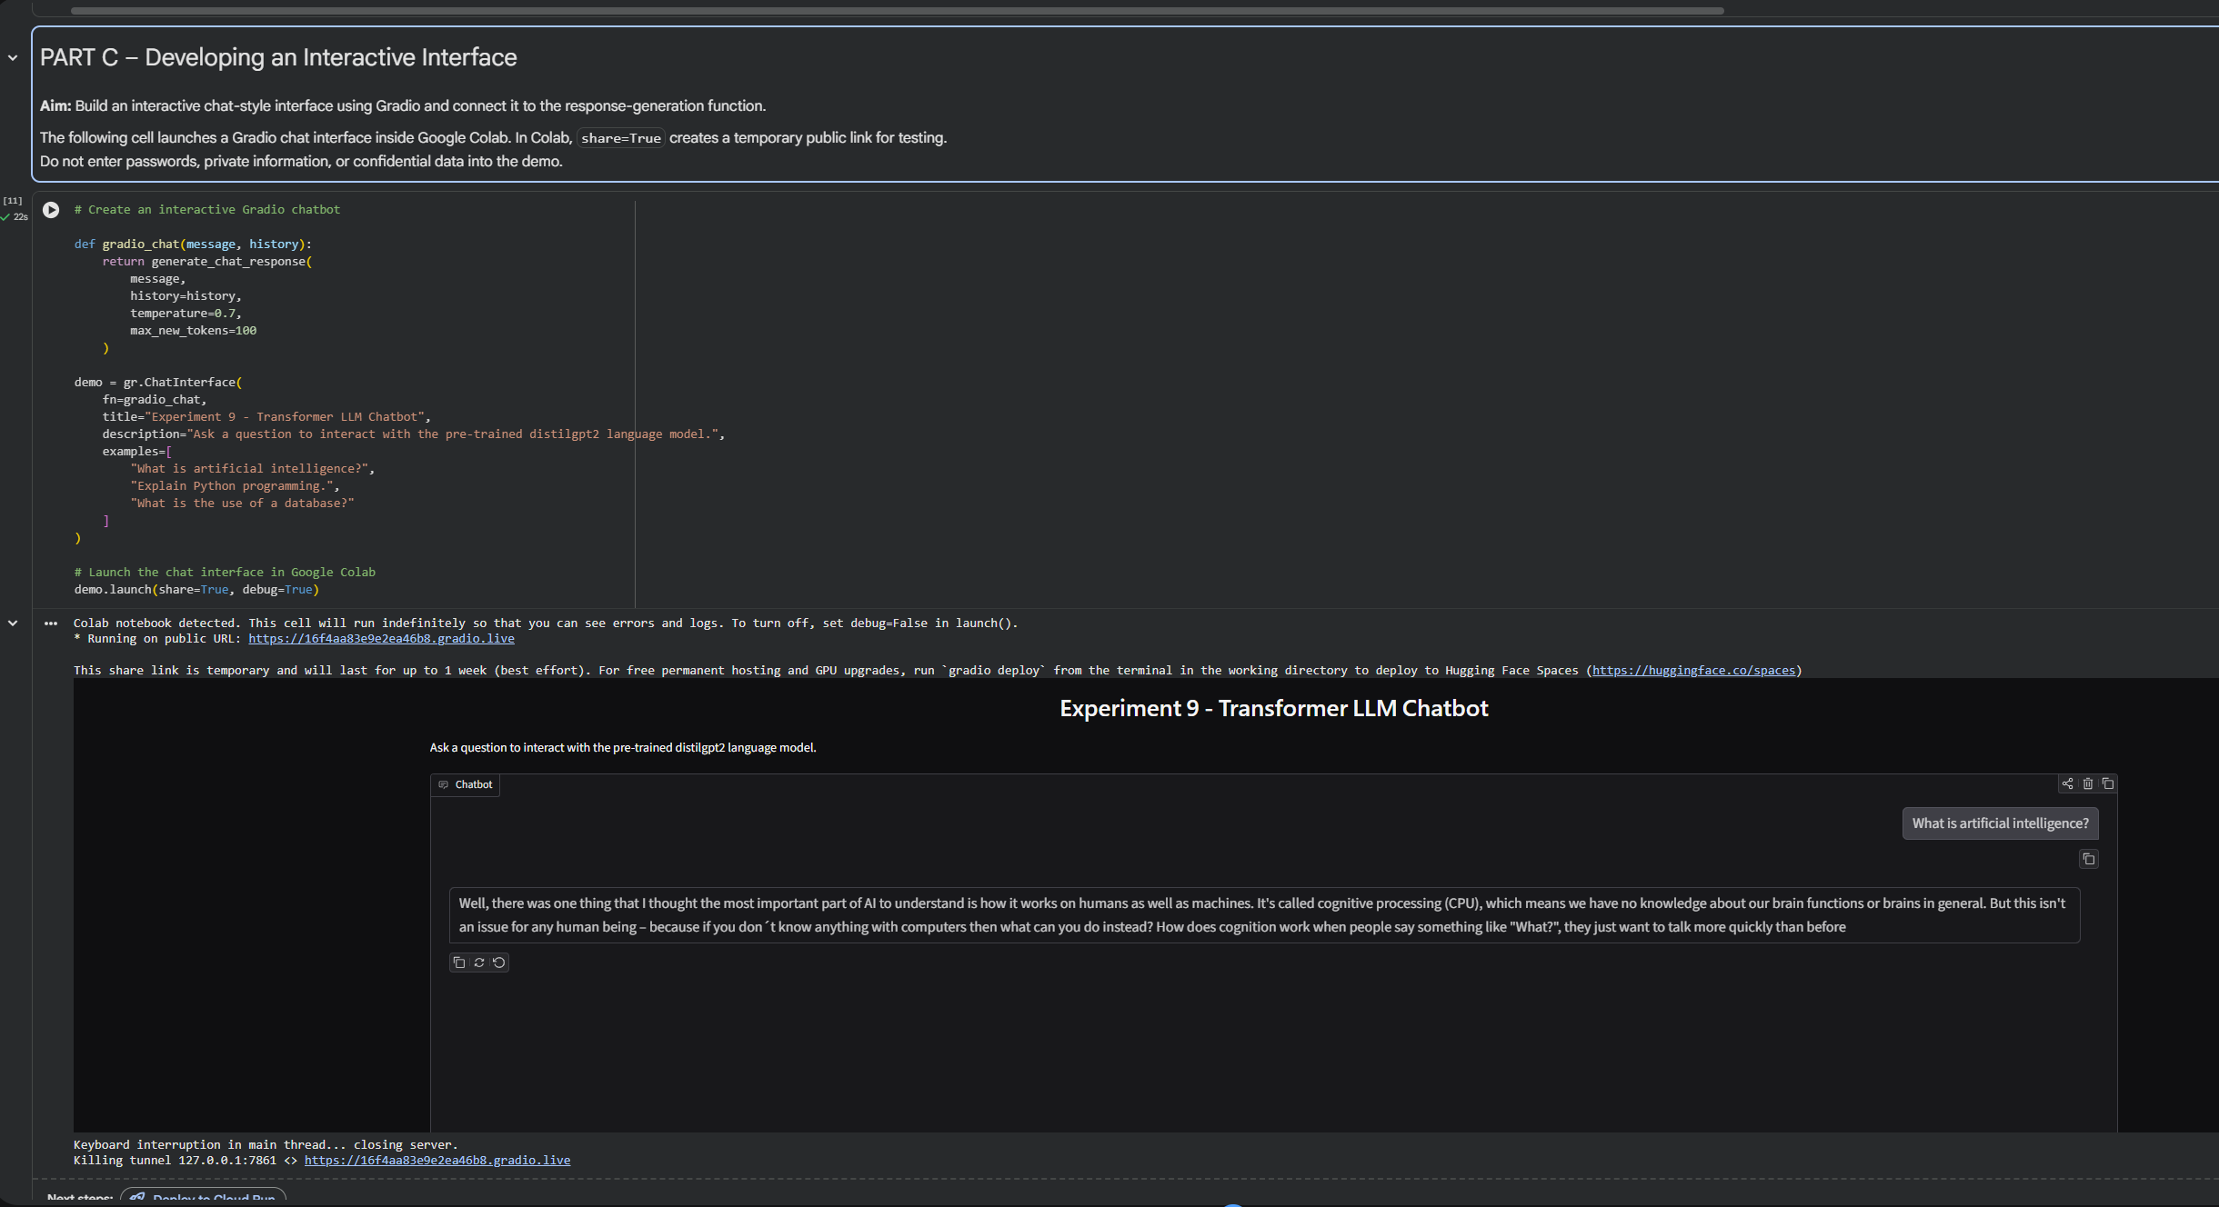

PART D: APPLICATION TESTING AND DEPLOYMENT

Perform the following tasks:
- Test the chatbot for response quality and usability.
- Observe limitations such as hallucinations and response latency.
- Organize the source code and create a requirements.txt file.
- Upload the project to GitHub.
- Deploy the application using a suitable platform, such as Hugging Face Spaces, if available.
- Document the results and limitations.

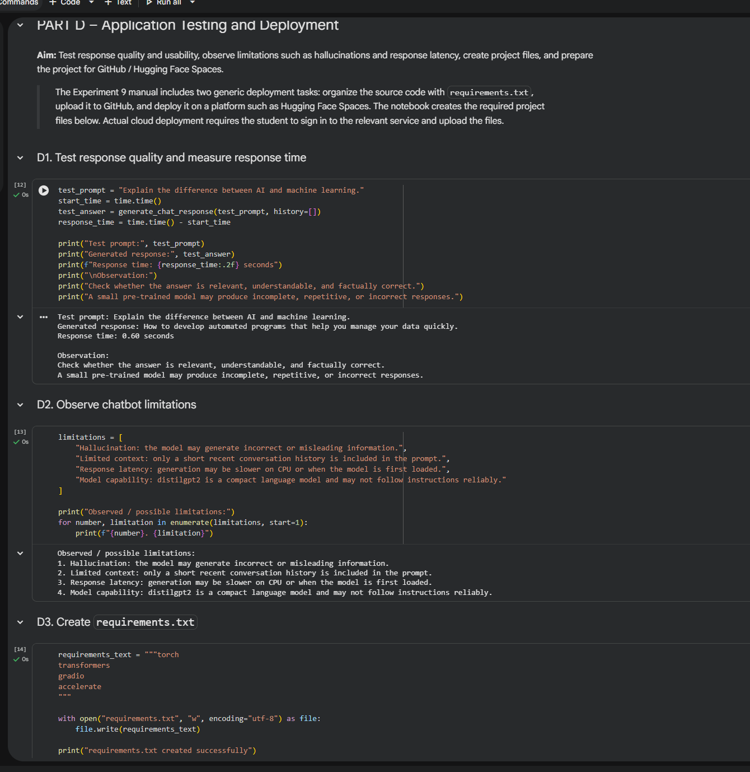

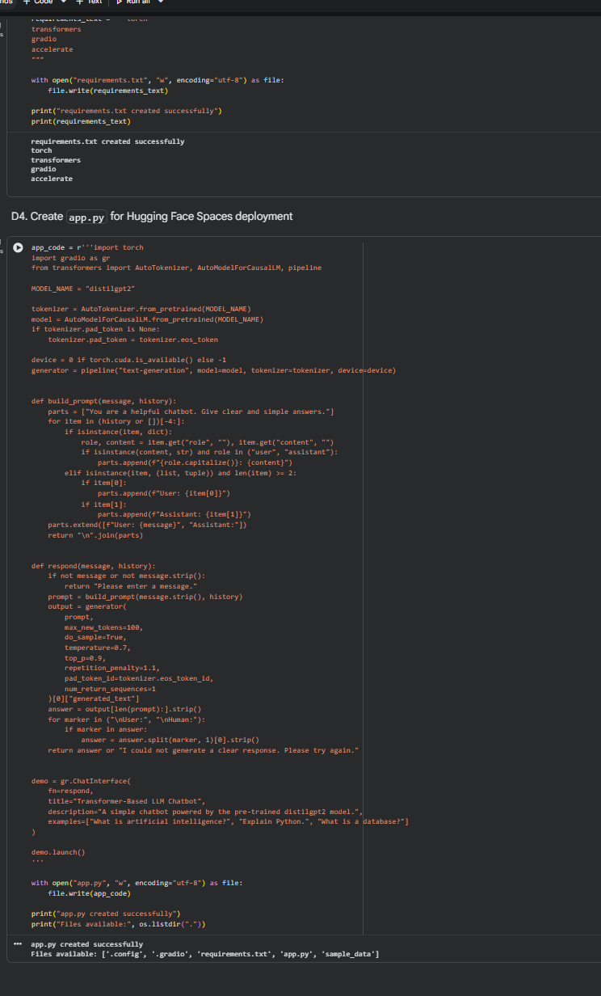

POST-LAB QUESTIONS (PROVIDE BRIEF ANSWERS TO THE FOLLOWING QUESTIONS)

- Explain how an LLM generates responses from user prompts.

An LLM converts the user prompt into tokens and processes them using Transformer architecture. It predicts the next token based on the context and continues generating tokens until the response is completed.

- What is the importance of conversation history in a chatbot?

An LLM converts the user prompt into tokens and processes them using Transformer architecture. It predicts the next token based on the context and continues generating tokens until the response is completed.

- Explain the effect of temperature on response generation.

Temperature controls the randomness of the generated text.
- Low temperature: Produces more predictable and focused responses.
- High temperature: Produces more creative and varied responses.

- Differentiate between local execution and cloud deployment.

Local Execution | Cloud Deployment
Runs on a personal computer. | Runs on a cloud server.
Mainly accessible on the local system. | Can be accessed through the internet.
Uses local system resources. | Uses cloud resources.
Requires local setup and installation. | Requires deployment and hosting setup.

- State two limitations of LLM-based chatbots.

- Hallucination: LLMs may generate incorrect or misleading information.
- Response Latency: Generating responses may take time, especially for large models or systems with limited computing resources.

ASSESSMENT
Description | Max Marks | Marks Awarded
Pre Lab Exercise | 5
In Lab Exercise | 10
Post Lab Exercise | 5
Viva | 10
Total | 30
Faculty Signature

